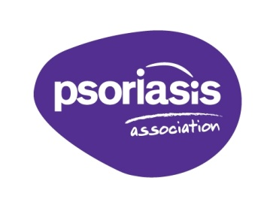
Annual Conference and AGM
Saturday 6th May 2017 10am – 4pm
Booking Form – Please return by 28th April 2017
Booking Details
Name(s) of those attending:
Address:
Tel no: Email:
Order Details
Number attending: _________ at £17.50 per person
❐ I enclose a cheque payable to the Psoriasis Association, for the amount of £
❐ Please charge my credit/debit card the amount of £ using the details below:
Cardholder’s Name: Card Number:
Start Date: Expiry Date:
Security Code (last 3 digits on back of card):
Issue Number (if applicable):
Complimentary refreshments will be served throughout the day including a buffet lunch.
Please state any special dietary requirements:
A free coach service will be available for delegates travelling by train to Milton Keynes Central Train Station on the day of the Conference. The coach will depart from the train station at 9.15am leaving Whittlebury Hall for the return journey at 4.15pm.
Places must be booked in advance.
Please reserve __________ seat(s) Name(s) of passengers:
Mobile Tel. for day of Conference:

