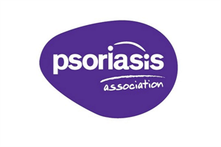
PSORIASIS NURSE OF THE YEAR AWARD

The BDNG, in collaboration with the Psoriasis Association, is delighted to welcome nominations for nurses who have delivered exceptional care and support to people with psoriasis.

The aim of this award is to raise awareness of the impact of psoriasis and to recognise one nurse for their work in helping those living with psoriasis.

The Award will be presented at the BDNG Annual Conference on 27 June 2018 and the nominator will be given the opportunity to present this in person.
Conditions of application
- This winner of this award must be a Registered Nurse
- The judging of this award is based solely on this nomination
- Incomplete nominations may not be considered
- Late nominations will not be considered
- The BDNG reserves the right to vary the conditions of application or to terminate the award
- The name of the winner will be published in Dermatological Nursing journal

Your name
Your email and/or telephone number
Name of the nurse you are nominating
Name of hospital or clinic where you visit your nurse
How long has your nurse been caring for you?
In a maximum of 200 words, please describe a time when your nurse went above and beyond the call of duty and treated you in an exceptional way

In a maximum of 200 words, please describe what personal qualities you believe that your nurse possesses which makes them so great at their work

In a maximum of 200 words, is there anything else you would like to add to your nomination?

Please send all nominations to admin@bdng.org.uk or BDNG, Forsyth House, Cromac Square, Belfast, BT2 8LA, UK

Closing date for applications is 1 June 2018

This award is funded by Celgene who will not receive your details and will not be involved in the judging process.
Privacy - The BDNG respects and recognises your right to privacy. The information that you have provided will only be used for the purposes of this award. Your details will not be shared and we will only retain it for as long as is necessary for this award. For further information about our privacy practices, please contact susan.maguire@bdng.org.uk

